**Module 1**

1. **What is software? What is software engineering?**

Software is set of instruction, data or programs used to operate computers and execute specific task. It is opposite of hardware, which describes the physical aspects of computer

The two main categories of software are [application](https://www.techtarget.com/searchsoftwarequality/definition/application) software and [system software](https://www.techtarget.com/whatis/definition/system-software)

**Software engineering** is the branch of computer science that deals with the **design, development, testing, and maintenance of software applications**. Software engineers apply engineering principles and knowledge of programming languages to build software solutions for end users.

2. **Explain types of software**

**Software** is a collection of instructions, data, or computer programs that are used to run machines and carry out particular activities

Among the various categories of software, the most common types include the following:

Application software. This software is a computer software package that performs a specific function for a user, or in some cases, for another application. An application can be self-contained, or it can be a group of programs that run the application for the user. Examples of modern applications include office suites, graphics software, web browsers, word processors, software development tools, communication platforms.

System software. These software programs are designed to run a computer's application programs and hardware. In addition, it controls the operations of the computer hardware and provides an environment or platform for all the other types of software to work in. The OS is the best example of system software.

Driver software. Also known as device drivers, this software is often considered a type of system software. Device drivers control the devices and peripherals connected to a computer, enabling them to perform their specific tasks. Examples include standard hardware, such as USB storage devices, keyboards, headphones and printers.

Middleware software. The term middleware describes software that mediates between application and system software or between two different kinds of application software. For example, middleware enables Microsoft Windows to talk to Excel and Word. It is also used to send a remote work request from an application in a computer that has one kind of OS, to an application in a computer with a different OS. It also enables newer applications to work with legacy ones.

Programming software. Computer programmers use programming software to write code. Programming software and programming tools enable developers to develop, write, test and debug other software programs. Examples of programming software include assemblers, compilers, debuggers and interpreters.

3. **What is SDLC? Explain each phase of SDLC**

Software Development Life Cycle (SDLC) is a framework that defines the steps involved in the development of software at each phase. It covers the detailed plan for building, deploying and maintaining the software.

SDLC Phases

1 Requirement gathering and analysis

2 Design

3 Implementation or coding

4 Testing

5 Deployment

6 Maintenance

1 **Requirement gathering and analysis :**

During this phase, all the relevant information is collected from the customer to develop a product as per their expectation. Any ambiguities must be resolved in this phase only. Business analyst and Project Manager set up a meeting with the customer to gather all the information like what the customer wants to build, who will be the end-user, what is the purpose of the product.

2 **Design :**

In this phase, the software design is created, which includes the overall architecture of the software, data structures, and interfaces.

3 **Implementation or coding :**

Implementation/Coding starts once the developer gets the Design document. The Software design is translated into source code. All the components of the software are implemented in this phase.

4 **Testing :**

Testing starts once the coding is complete and the modules are released for testing. In this phase, the developed software is tested thoroughly and any defects found are assigned to developers to get them fixed.

5 **Deployment :**

After successful testing, the software is deployed to a production environment and made available to end-users.

6 **Maintenance :**

After the deployment of a product on the production environment, maintenance of the product i.e. if any issue comes up and needs to be fixed or any enhancement is to be done is taken care by the developers

4. **What is DFD? Create a DFD diagram on Flipkart**

**DFD** is the abbreviation for **Data Flow Diagram**. The flow of data of a system or a process is represented by DFD. It also gives insight into the inputs and outputs of each entity and the process itself.

Given Below are the DFD diagram of Flipkart

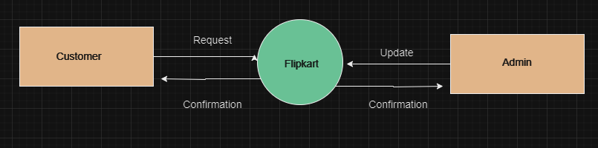

**Level 0 DFD**

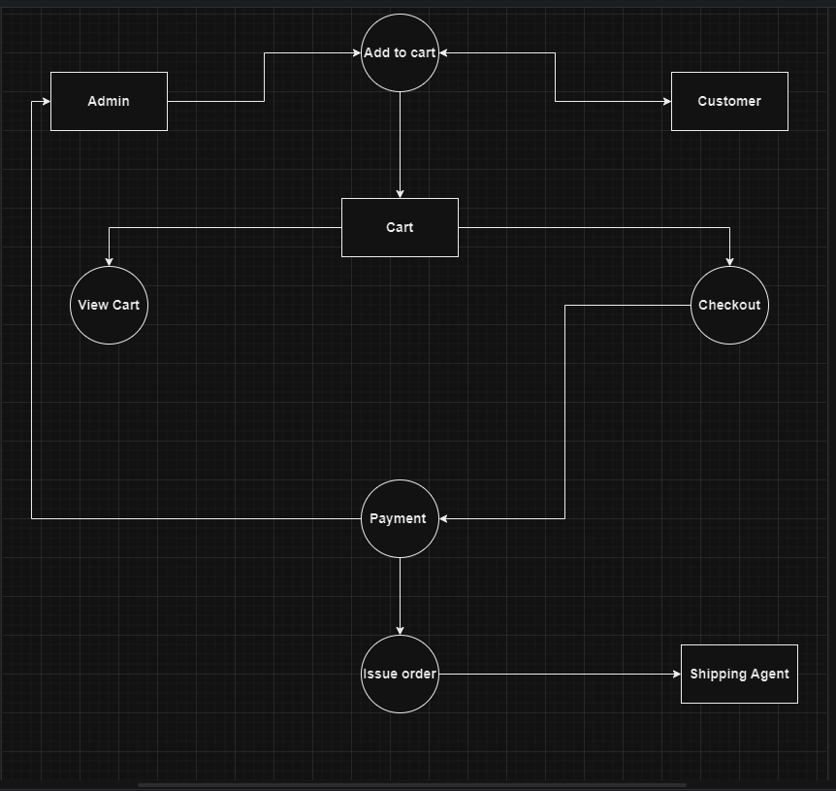

**Level 1 DFD**

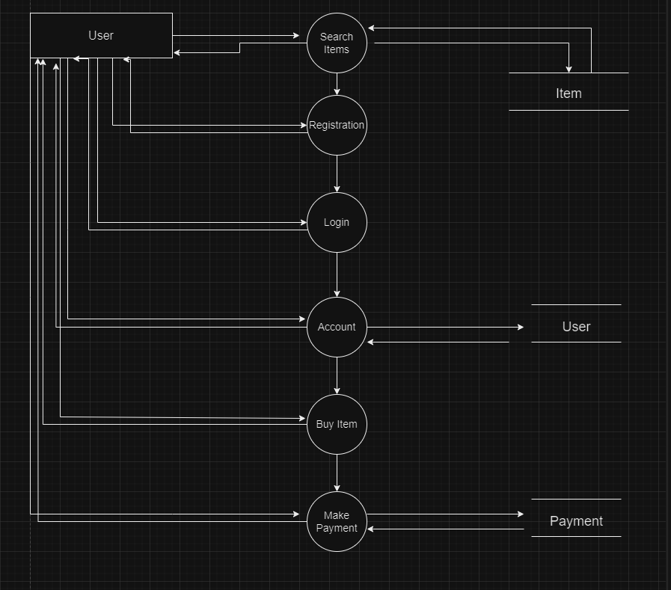

**Level 2 DFD**

5. **What is Flow chart? Create a flowchart to make addition of two numbers**

**Flowcharts** are nothing but the graphical representation of the data or the algorithm for a better understanding of the code visually. It displays step-by-step solutions to a problem, algorithm, or process.

It is a pictorial way of representing steps that are preferred by most beginner-level programmers to understand algorithms of computer science.

Given below is the flowchart of addition of two numbers.

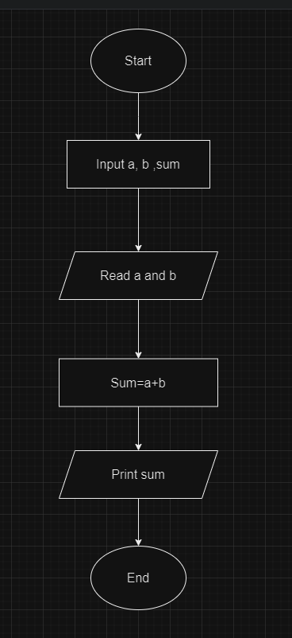

6. **What is Use case Diagram? Create a use-case on bill payment on paytm.**

A Use Case Diagram is a vital tool in system design, it provides a visual representation of how users interact with a system.

A Use Case Diagram is a type of Unified Modelling Language (UML) diagram that represents the interaction between actors (users or external systems) and a system to accomplish specific goals.

